Bell JetRanger 206B III (N192TA)

● GPS: POSTrack with IMU -Garman 430 Moving Map
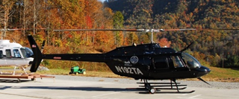
● Ryan 9900B TCAS
● Engines: Air Research Jet
● Max Working Elevation: 13,000’ MSL
● Speed: 80-120 knots
● Runway: Vertical

