Piper Navajo Panther 310 (N190TA)
● Cabin: unpressurized
● GPS: POS AV with Dual Frequency Garmin GPS and IMU
● GPS: Garmin 530 Moving Map
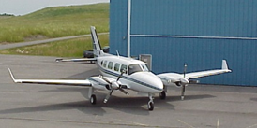
● Ryan Collision Avoidance System
● Engines: Lycoming 350 Hp
● Max Working Elevation: 24,000’ MSL
● Speed: 130-170 knots
● Runway: 2,000’
● Dual Port (Nose and Mid-Cabin)

