Bell LongRanger LIII Helicopter (N194TA)

● GPS: POSTrack with IMU
● Garman 530 Moving Map
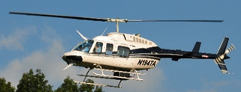
● Ryan 9900B TCAS
● Engines: Air Research Jet
● Max Working Elevation: 13,000’ MSL
● Speed: 80-130 knots
● Runway: Vertical
● Azimuth Mount

