Cessna 206 Stationair II (N193TA)
● Cabin: unpressurized
● GPS: Leica Navigational System with Dual Frequency Garmin GPS and IMU
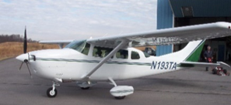
● GPS: Garmin 530 Moving Map
● Ryan Collision Avoidance System
● Engine – Continental 550 300 Hp
● Max Working Elevation: 15,000’ MSL
● Speed: 100-140 knots
● Runway: 2,000’
● Single Port

